Miguel Fernandez Brazon
Module 7.2 Assignment 2/22/26
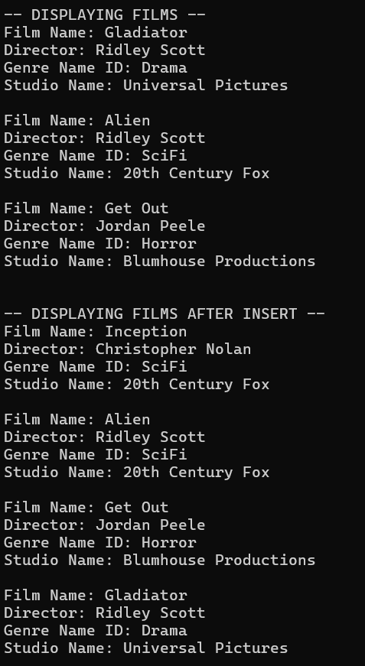
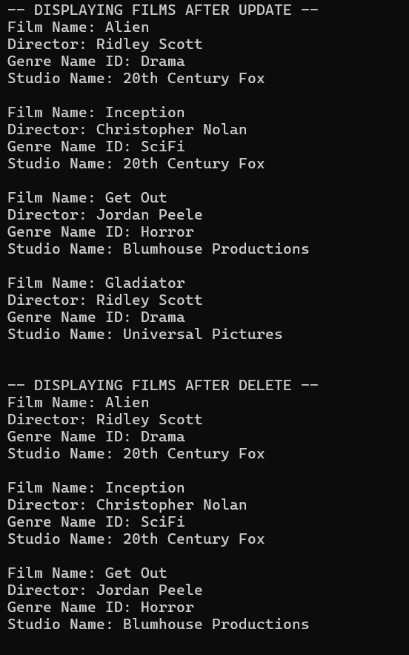
GIT-https://github.com/concord808030-tech/CSD310-300O-

